Friday 8th January 2021
Describe the wizard
Use these pictures to help you.
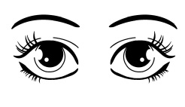

Remember:
- Use a sentence.
- Finger Spaces
- Capital Letters
- Full Stops
- Read your writing. Does it make sense?

