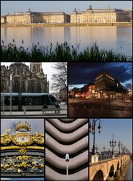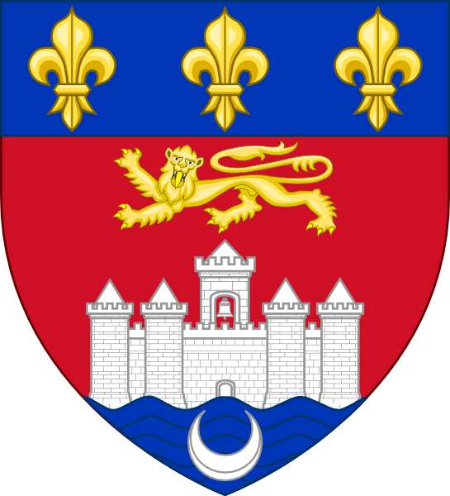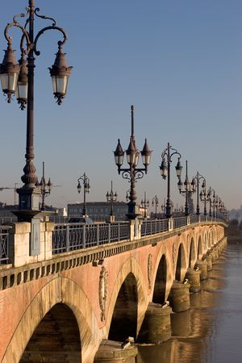

Written by …

### fULL OF HISTORY



A bit of history here



# Bordeaux

## France

## A bustling city…

A bit about the city – facts and figures here…..

An excellent place to visit

We make you go Round the WORLD

Phone: (425) 555 0125

## You can see

### 

### A bit about different sights here

## You can eat

### 

### A bit about different FOODs here

## The weather

### 

### A bit about the climate here